Save the Railway Arms Pub
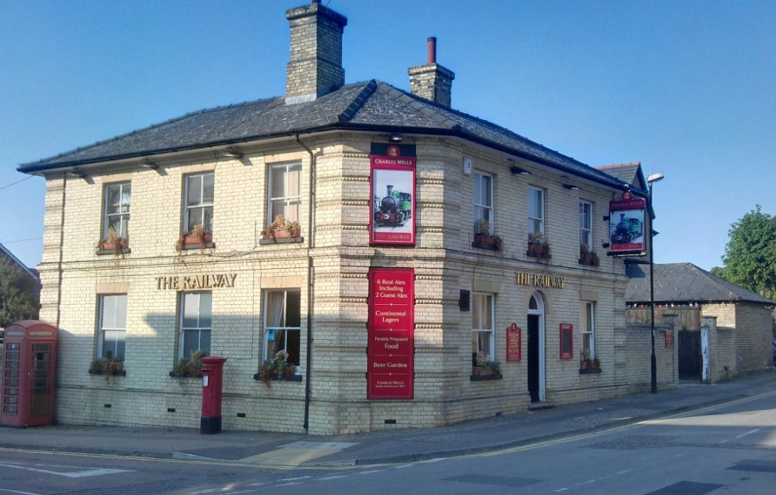
It is proposed to establish a Community Benefit Society (‘CBS’) with the purpose of purchasing the Railway. If you think that you would be interested in becoming a member of CBS and investing in the company, please complete the details below.
When completed, please return it to the Saffron Walden Tourist Office or post it to Tom Bennett (Treasurer), STRAP, 89 High Street, Saffron Walden, Essex, CB10 1DZ.
In any event please respond by Friday 12th May 2017 so that we can move things forward.
This information will be used purely to enable the steering group to gauge the potential level of support for this venture.
It will be treated confidentially. It does not constitute a commitment to invest.
The proposed company structure and its formation will require the approvals of the Financial Conduct Authority (FCA) and Revenue and Customs (‘HMRC’) and we will receive professional advice in doing this. In due course a formal Prospectus will be made available.
It is currently intended that the shares purchased will pay an attractive rate of interest and that they must be held for a minimum of 3 years.
If you would like more information please email Dave Kenny [Chairman] at: davekenny@gmx.com

Name: |  |  | Address:
email address:
Phone : landline -
: mobile -
Possible amount of investment | □ | □ |  | □ | □ |  | □ | ￡
 | £50 | £250 |  | £500 | £1,000 |  | £5,000 | other ( please specify amount)
(Any comments or suggestions?)

