Pub Manager
A unique opportunity to be the First Pub Manager of our soon to be launched Community Pub
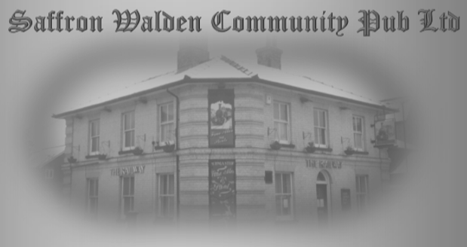
Attractive package including bonus scheme and the option of live in accommodation.
The Railway Arms is a Community led and managed pub in the beautiful town of Saffron Walden, North Essex, a hub for the community that’s being totally being refurbished and is aiming to be ready for business around mid April (COVID restrictions allowing).
Our initial aim is to re-open a completely renovated and traditional wet led pub, which will offer services and facilities that include:
- Bar and eating area capable of serving around a dozen tables
- An extensive courtyard, garden and patio with space for around twenty table benches
- If desired, an unfurnished flat will be available on site
- Going forward, in keeping with the ‘More Than a Pub’ principles, the development of all the outbuildings on site to offer a range of community based services with the pub at the heart of the hub
Just as importantly, our pub offers a unique career opportunity for the right person/couple:
- The unquestionable support of a friendly and pro-active local community and the desire to work closely with you to fully develop the pub’s potential as a community hub
- A real ‘free house’, free of any brewery or pub company tie on all products
- A unique management opportunity to really help shape the development and growth of the pub
- A great location in the attractive and historic town of Saffron Walden, the pub is located a few minutes walk from the town centre

ABOUT YOU:
We are looking for an individual or a couple who will be responsible for ensuring fantastic levels of service are always maintained. Previous experience of pub management, hospitality or working in a community based business would be beneficial. Key responsibilities include:
- Assist with the promotion of The Railway Arms to ensure recognition as a community operated pub, working together with the Community Benefit Society and Pub Management Committee
- Overall responsibility for all staff to create a welcoming environment and correct ambience, which will contribute to achieving the highest professional standards.
- Drive sales, cash management and reconciliation with accuracy and high levels of security
- Awareness of changing Legislation relevant to the business, particularly with regard to Food Handling Standards and Health and Safety and latest COVID 19 regulations
- Event experience, both organising and running events

MUST HAVES:
- Some relevant experience in a busy, customer facing environment
- High customer service skills and an ability to build and maintain relationships with the local community and customer base
- Experience organising and running events
- Being calm under pressure
- The ability to create a motivated, yet fun working environment for the team
- A strong interest and commitment to the community run ethos
If all of this sounds exciting and of interest, we’d welcome a conversation with you about your ambitions and vision, and we can talk about where we are now with the ongoing development of the pub. Further information about the pub and our community project can be found here: strap.org.uk
Also, we would like to know a bit more about you: To express your initial interest, please visit our website, strap.org.uk where you can download a recruitment pack. On completion of your application, as outlined in the recruitment pack, please return it to: recruitment@strap.org.uk

