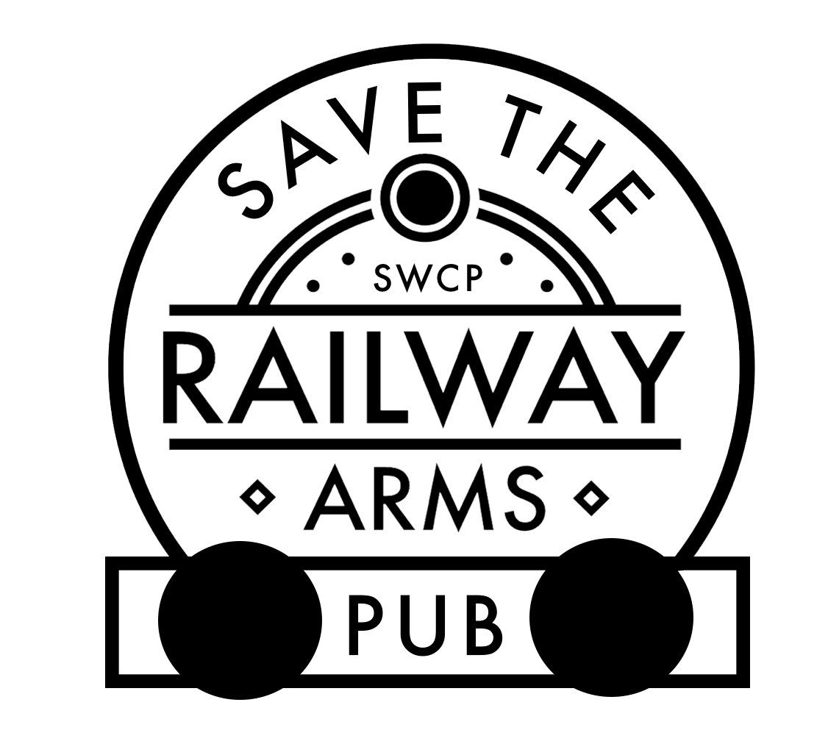
Save the Railway Arms Pub
Pledge Form
What is it all about?
- You are being invited to make a pledge to buy shares in the Saffron Walden Community Pub Limited (‘SWCP’)
- SWCP was established to purchase, refurbish and reopen the Railway Arms and safeguard the future of a key community amenity
- SWCP is a community benefit society, owned and run by the community for the benefit of the community and regulated by the Financial Conduct Authority [FCA]
Why do it now?
- The pub has been registered as an Asset of Community Value [ACV]
- The owner, Charles Wells, has decided to put it up for sale [again]
- The community now has until 20th June 2020 to submit a community bid before other non- community groups can make an offer
How would it be done?
- Raise funding via a second community share issue
- Re-applying for grants and mortgage finance
- Maximise the share sale as it is cheaper than mortgage or loan finance
- Follow the path identified by the Plunkett Foundation who has assisted other communities to do this
How does the share sale work?
- A share prospectus will be issued shortly
- Shares can be purchased for £50 per share
- The minimum subscription is £50 (1 share) and the maximum up-to £50,000 (1,000 shares)
- Shares bear interest at initial rate up to 3.0% per annum, paid gross
- Rate fixed annually based on market conditions and performance of SWCP
- After 3 years shares are eligible for withdrawal, by giving 3 months’ notice to SWCP
- Withdrawal may be declined, or amount reduced if the withdrawal threatens the future of the SWCP
- Tax paying investors may benefit by being able to claim tax relief on their investment under the Enterprise Investment Scheme [EIS]
- HMRC provided advance authorisation for EIS on the first share offer and advance assurance will be sought for the second share issue.
Will SWCP be viable?
- Community owned pubs are based on a new business model that is more customer [community] focused and operate on a lower cost basis than pubs owned by breweries or pubcos.
- SWCP has prepared a business plan detailing how the pub will be run on a financial sustainable basis and includes developing the pub and the outbuilding to improve the services provided and income raised
What do you need to do now?
- Visit www.strap.org.uk; Facebook (savetherailway1) or twitter (savetherailway1) to find out more information on the proposal including the business plan and community benefit plan.
- Complete and return the following form to the Saffron Walden Tourist Information Office or post it to Tom Bennett (Secretary), STRAP, 89 High Street, Saffron Walden, Essex, CB10 1DZ as soon as possible.
This information will be treated confidentially and used purely to gauge the potential level of funding for this venture.
It does not constitute a commitment to invest

Save the Railway Arms Pub
Pledge Form
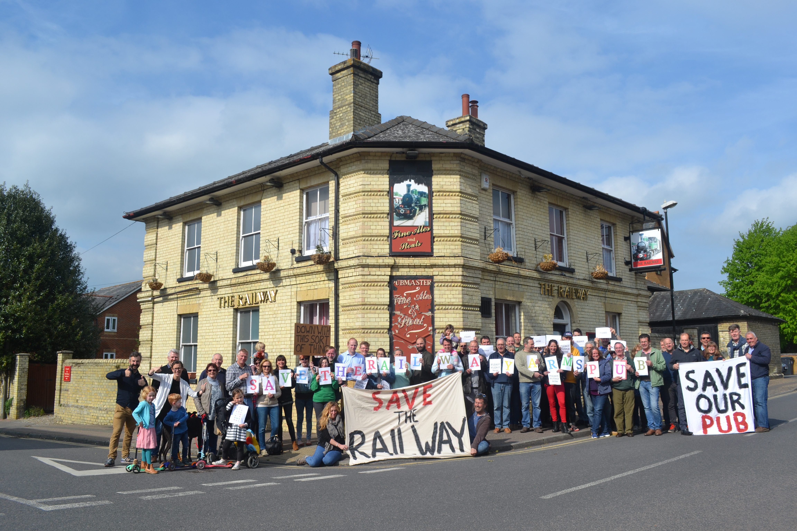

Name:
Address:
Post code
email address:
Phone : landline:
: mobile:
Possible amount of investment | £50 | £250 |  | £500 | £1,000 | £5,000 | £10,000 | £20,000 | other

 | □ | □ | □ | □ | □ | □ | □ | £

If you need further information, please contact Dave Kenny (Chairman) at davekenney@strap.org.uk
Return the form to the Saffron Walden Tourist Information Office or post it to Tom Bennett (Secretary), STRAP, 89 High Street, Saffron Walden, Essex, CB10 1DZ as soon as possible.
This information will be treated confidentially and used to gauge the potential level of funding for this venture.
It does not constitute a commitment to invest

