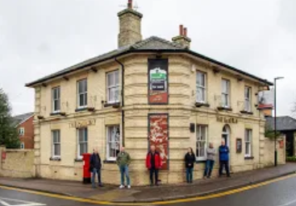

Perhaps you would like to run a unique and historic pub in a pleasant and attractive town that will be community-owned, refurbished and ready for business?
If so, you may have found what you’re looking for in The Railways Arms in Saffron Walden, North Essex.
We believe that pubs are vital assets to their communities for the long term. The Railway Arms, is owned by Saffron Walden Community Pub Ltd, a community benefit society created to operate the Railway Arms on a managed basis. Its purpose is to ensure the pub is run in accordance with the Society’s aims and values including;
- Ownership by the community, setting the direction and values of the pub
- An offering that is attractive and accessible to all
- Promoting social inclusion
- Financially viable for the long term
As a community run pub, it offers the potential for a genuine and long term business partnership which is widely supported by the town. We have over 500 shareholders who have invested in the pub, plus the full support from our friendly proactive management committee.

SWCP organisation and Structure
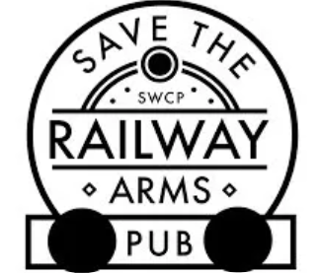

The Saffron Walden Community Pub is set up and structured in the following way:
Community shareholders: Shareholders, customers and the local community who have an interest in the successful running of the Railway Arms.
Management Committee: Responsible for the overall running of the company and the Railway Arms in line with the Society’s governing document, aims and values.
Business Manager: Ensuring provision of the pub’s operation on behalf of the Management Committee and in line with the Society’s aims and values; compliance with statutory obligations and providing controls on costs and revenue.
Pub Manager: Managing the day-to-day operation of the Railway Arms; both delivering the day-to-day services of the pub and developing community engagement and services.

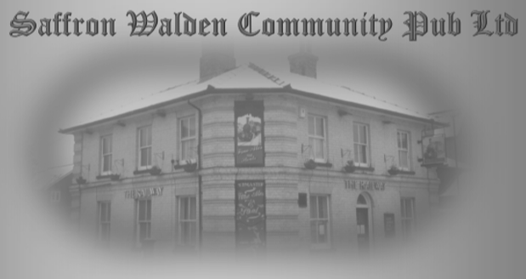

Background
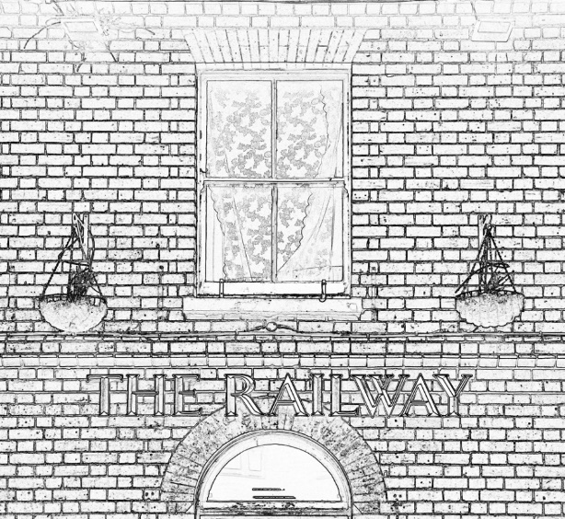
The Railway Arms closed in 2017 and the owner’s objective was to sell the property for private development. The local community was devastated by this decision and it wasn’t long before a committee was formed to ‘Save the Railway’. It received immediate support raising close to 300K which enabled the committee to eventually purchase the pub.
The deal was finally done in October 2020, when we received the keys, and since then, we have been focused on restoring the pub to its former glory as a ‘go to’ pub renowned for great beer and fantastic pub food.

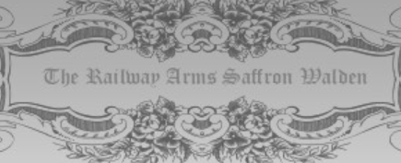

Current Position
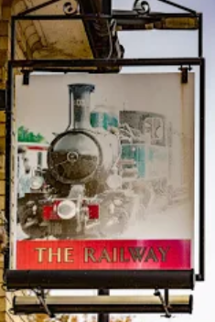
We are working hard to do everything we need to do to open the doors for business as soon as COVID restrictions allow.
The plan is to re-open a completely renovated and traditional wet led pub, which will offer services and facilities that include:
- Bar and eating area capable of serving around a dozen tables
- Good food which is accessibly priced for all members of the local and wider community
- An extensive courtyard, garden and patio with space for around twenty table benches
- If desired, an unfurnished flat will be available
- Going forward, the development of all the outbuildings on site to offer a range of community based services and events with the pub at the heart of the hub
Just as importantly, our pub offers a unique career opportunity for the right person/couple which will actively follow the ‘More Than a Pub’ principles:
- A real ‘free house’, free of any brewery or pub company offering a range of well kept beers and ciders
- A unique management opportunity to really help shape the development and growth of the pub
- A great location in the attractive and historic town of Saffron Walden, the pub is located a few minutes’ walk from the town centre
- The unquestionable support of a friendly and pro-active local community and the desire to work closely with you to fully develop the pub’s potential as a community hub. We are all determined to see you succeed!

Our Vision
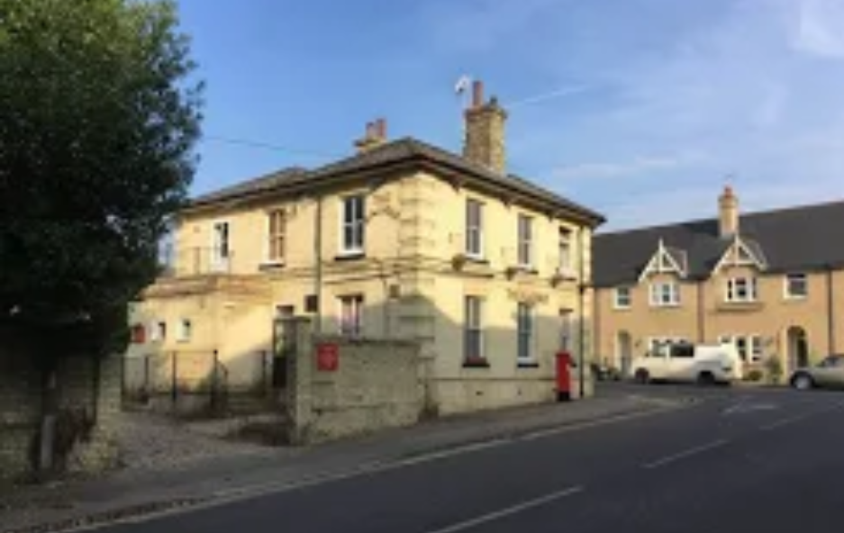
Reopening The Railway Arms and making this a success, we see as only the beginning. The pub enjoys a large garden, the largest of any hospitality business in Saffron Walden, and also has a number of historic outbuildings. The combination of the space available and outbuildings offer enormous potential to further develop the pub into a community hub in time. The vision is to develop the pub and outbuildings into new and innovative areas for the town including:
- A Stables Bar benefitting from the retained, fully exploited, original features which could open out onto an attractive, car free, courtyard.
- A Hayloft music/meeting/function room which would be accessed through an enlarged entrance via a staircase from the Stables Bar.
- A Community Shop in the Coach House with an embedded small coffee and cake cafe. There are no such facilities close by.
- A Workshop/Men’s Shed/Repair Shop or Repair Café/Library of things utilising the workshop and garage.
- To actively promote a Green agenda by introducing initiatives such as an electric car charging point, fitting solar panels and bike racks.
For now, simply having the pub back open will do wonders for the town.
Everything our Society earns will go to making sure The Railway Arms and the site fulfils this vision, together with your vital support and input, which, in turn will help make the surrounding area a better place to live.
We see a bright future for pubs, owned and maintained by communities who treasure them, boosting the local economy and providing jobs for local people. We’re looking for a managing partner to help make this happen. If you share this vision and can help build a business that benefits the community as well as yourself, this could well be you…
If you like the sound of this and think you’d like to build a great pub and community hub business with us, please do complete and return an application form. For more details, the full business plan is available on the website and we would welcome your thoughts on this exciting project.
We’ll be very happy to sit down with you and discuss in detail your ambitions and where we are now.
But first, we need to know a bit more about you. We have a simple recruitment process:
- Please download the recruitment pack and, if you would like to apply, please complete and return the application form to recruitment@strap.org.uk.
- On receipt of your application form, we will contact you as soon as we can, aiming at within a week.
- For successful applicants, we will be holding first interviews later in March, hopefully in the pub, COVID restrictions allowing.
- We anticipate that our new Pub Manager will be appointed and be helping with our launch plans by the end of April at the latest.
- Please understand that we expect to receive a huge amount of interest and a large number of applications for this opportunity. Whilst we endeavour to deal with all enquiries as quickly as possible, please understand that we cannot guarantee a personal reply to all applications.
Thank you for your time and interest in The Railway Arms. We are very excited to be recruiting our first Pub Manager and we look forward to receiving your application(s) and meeting you soon!
